Working Group 2

Author : |  | Christian GIRAUD |  | Date : | 28/10/2013
Subject : |  |  |  |  |  |  | Document Review : |  | ☑
OpenETCS WP3 Task Force |  |  |  |  |  |  | Design Review : |  | ❒
WG 3 Architecture - provisional - |  |  |  |  |  |  | Other :

Name | Position | Company / Department
Valerio Raimondi |  | Alstom
Stephane Besure |  | Alstom
Nicolas Boverie |  | Alstom
Christian Giraud |  | Alstom
Yoann Guyot |  | Cetic
Baseliyos Jacob |  | DB
Bernd Hekele |  | DB
Niklas Schaffrath |  | Siemens
Uwe Steinke |  | Siemens
Jos Holtzer |  | NS
Jan Welvaarts |  | L’loyds Register Rail
Sylvain Baro |  | SNCF
Marielle Petit-Doche |  | Systerel
Jan Welte |  | TU Braunschweig

Distribution to:
Name | Position | Company / Department
 |  | Alstom TIS

Table of Content

1. Speed Supervision limits 3
1.1 references 3
1.2 overview 3
1.3 Context of Speed Supervision Limit 3
1.4 Example of Balise Group in level 1 5
1.5 EB Supervision Curve 5
1.6 EB Supervision Computation 5
1.7 EB Supervision Excel File 7
1.8 EB Supervision per Quantum 10

Speed Supervision limits

references
UNISIG Subset_026 version_3.3.0
Chapter 3 : ERTMS / ETCS Principes
Chapter 5 : ERTMS / ETCS Procedures
Chapter 7 : ERTMS / ETCS Language

overview
[SRS-026-chapter : 3.13.9.3]
Braking to target supervision limits consists in computation of EBD, EBI, SBD and SBI curves. GUI curve is not addressed.
The use of an Excel database is involved in this exercise.
The technics to fill up the database starting from balise contents is not approached.

The structure of the database is defined and Excel capabilities such as classification of data lists following increasing or decreasing abscissa are used.
We shall start from a typical BG of 2 or 3 balises that are crossed by one train in level 1.

This BG will provide basic data packets such as :
- National values,
- Movement Authorization,
- Balise linking,
- Speed Profile,
- Gradient Profile,
- Level Order,
- Temporary Speed Restriction.
- etc…

Context of Speed Supervision Limit
The context is defined with SysML diagram through one BDD (Block Diagram Definition) and several IBD (Internal Block Diagram) that will need to be linked with other parts of the OpenETCS definition.

The Block Diagram Definition should be composed of the 18 functions of the subset-026 chapter 3.

The Speed Supervision Limit is composed of the following block and its IBD :

Speed Limit
Supervision
Fixed Values
National Values
SSP Profiles
Gradient Profile
Temporary Speed Restriction
Track Condition Profile
Speed & Position & LRBG
LOA, Veoa, DP, OL
Current Mode & Mode Profile
Emergency Brake Curves
Service Brake Curves, S, W, P, I
Overspeeding

Block “Speed Limit Supervision” and IBD first level

Database
computed
Database
classified
Database
not classified
Traction and Brake
Model
Fixed Values
National Values
SSP Profiles
Gradient Profile
Temporary Speed Restriction
Track Condition Profile
Speed & Position & LRBG
LOA, Veoa, DP, OL
Current Mode & Mode Profile
Emergency Brake Curves
Service Brake Curves, S, W, P, I
Overspeeding

Example of Balise Group in level 1
We shall show an example of database configuration for a Balise Group in level 1.
- In first, we shall deploy the database following the singular points that are involved within the BG. We shall see that is not fully meeting the requirement of an EB deceleration variable with the speed.
- In second, we shall deploy the database by quantum of 10 meters.
Definition file of such BG is given chapter 1.6.

EB Supervision Curve

All parameters for braking to target supervision limits for EBD curve are defined within the drawing hereafter :

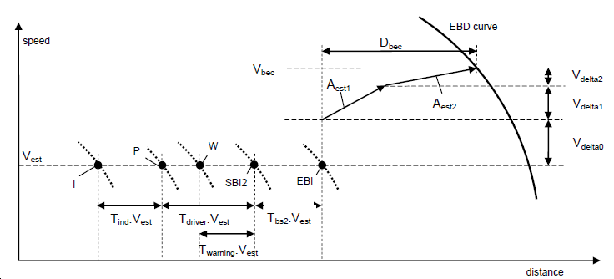
Origin :
,x0, v0, h0
Braking :
xb, vb, hb
Target :
x1, v1, h1

EB Supervision Computation

It is defined 3 particular locations :
- Origin :
  - x0 : location where the EB intervenes,
  - v0 : speed at location x0, so-called “Vest”, can be increased by inaccuracy,
  - h0 : hight of gravity centre at x0.
- Braking :
  - xb : location where the EB is active after two phases of transition,
  - vb : speed at location xb, is v0 increased after 2 phases of transition,
  - hb : hight of gravity centre at xb.
- Target :
  - x1 : target location,
  - v1 : target speedn
  - h1 : hight of gravity centre at target.

The next computation will be done through physical mechanic theory in “Energy” by mass unit (m²/s²) between origin and target. To define the EB supervision limits, we put the following equation :

(Brake_Energy) + (Potential_Variation_Energy) > (Kinetic Variation Energy) + (Response_Correction)

Cumul_EB > Cumul_K

With the following development :

  - Kinetic Variation Energy = ½ (v0² - v1²)
    - this value concerns the total mass : M * (1+alfa)
    - alfa can be a function of position “x”.

  - Brake Energy = (x1 – x0) * Aeb
    - this value concerns the total mass : M * (1+alfa)
    - Aeb is the average value of the function Asafe(x,v)
    - Asafe(x,v) needs to be integrated between x0 and x1
    - what about v ? (speed at origin x0 or something else )

  - Response_Correction = ½ [ (Aest1* T1)² + (Aest2*T2)²] +(Debc * Aeb)
    - response is in 2 phases, lasting T1 and T2,
    - the running distance is so-called Debc,
    - brake energy over Debc must be added to kinetic energy
    - power energy (Aest1 and Aest2) must be added too.

  - Potential _Variation_Energy = (h1 – h0) * g / Alpha
    - this value concerns only the mass M,
    - g = 9,81 m/s² must be taken into account,
    - potential energy must be compensated by division with Alpha = 1+alpha,
    - h1 – h0 is the integration of function Grade(x) between x0 and x1.

EB Supervision Excel File

The use of an Excel database is involved in this exercise in 3 steps :
  - Step 1 : to acquire data from balise content,
  - Step 2 : to classify acquired data into another file,
  - Step 3 : to simul.

Step 1 Excel File :
______________
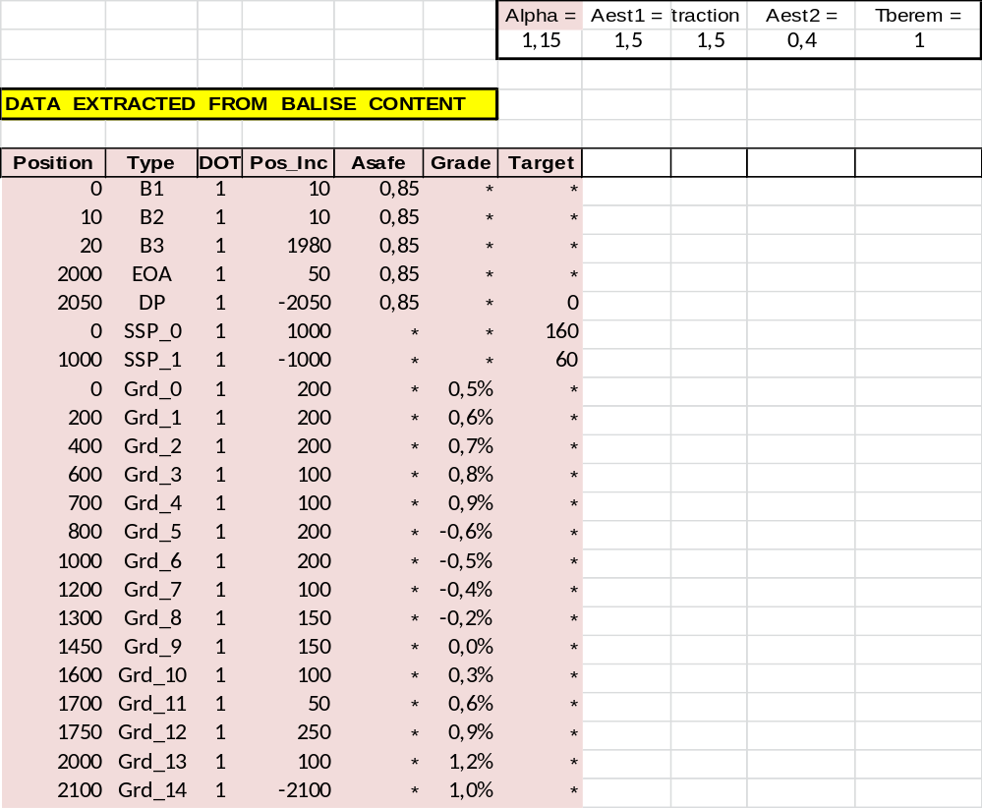

Position is the distance of singular point from the reference balise B1,
Type is the nature of singular point,
DOT is the Direction of Travel.
Pos. Inc. is the incremental position to the next singular point.
Asafe is the safe deceleration value of the Emergency Braking, related to increment.
Grade is the slope value which permits hight computation, related toincrement.
Target is the singular point of MRSP or a DP which can be a potential target.

Step 2 : singular point of database are classified following increasing position.

Step 3 : computation of final parameters.
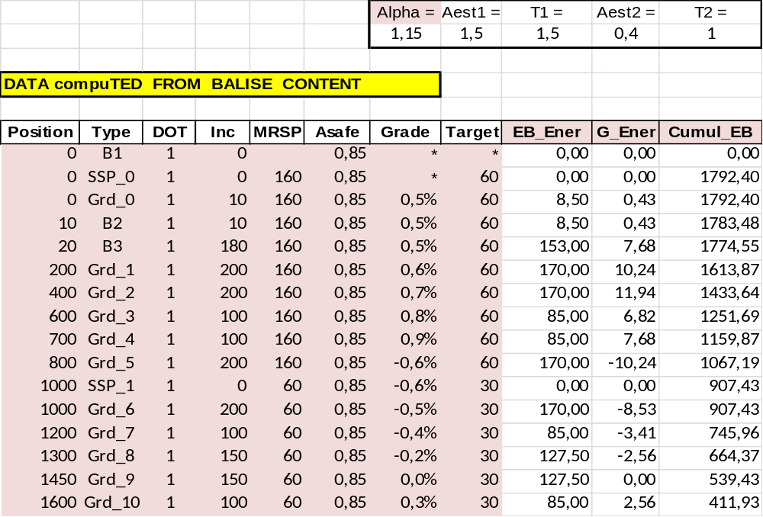
EB_Ener is the Emergency Brake Incremental Energy.
G_Ener is the Gravitation Incremental Energy.
Cumul_EB is the sum of EB and G energy variation from target DP to current position.
K_Ener is the Kinetic Energy variation from target DP to current position.
Debc is the running distance during both transition.
Corr_E is the increased transition energy.
Cumul_K is the sum of Kinetic and Transition Increased Energy.
E_Maxi is the minimum of both “Cumul”.

SSP_1 60 km/h is intermediate target and DP is the final target.

EB Supervision per Quantum

We come back on previous equations :

(Brake_Energy) + (Potential_Variation_Energy) > (Kinetic Variation Energy) + (Response_Correction)

In order to eliminate the response correction, we shall take in consideration the energy between target ”x1” and current location “xb”. That gives :

(Brake_Energy_B) + (Potential_Variation_Energy_B) >= (Kinetic Variation Energy_B)

and vb <= MRSP(xb)

With the following development :
  - Kinetic Variation Energy B = ½ (vb² - v1²) ( v1 is target, vb is current v )

  - Brake Energy B = (x1 – xb) * Aeb (integration from xb to x1)

  - Potential _Variation_Energy_B =(h1 – hb) * g / Alpha (integration xb – x1)

The process is to define “vb” from the target location (basically the Danger Point DP) up to the balise location. Then we have at the begining :

  - ½ (vb² - v1²) = (x1 – xb) * Aeb + (h1 – hb) * g / Alpha or
  - vb² = v1² + 2 * [(x1 – xb) * Aeb + (h1 – hb) * g / Alpha] and
  - vb <= MRSP(xb)

Starting from DP location (or EOA), to define “x1”,
v1 = 0 or Vsig,
h1 =0
Then to compute vb for each “xb” iteration, with a limitation by MRSP.
When previous MRST is higher, we have a new target.

Then the EBI curve can be computed through Debc and V_delta computation:
V_delta = Aest1*T1 + Aest2*T2
v0 = vb – V_delta
Debc = ½ ( Aest1 * T1² + Aest2 * T2² ) + v0 * (T1 + T2)
x0 = xb – Debc
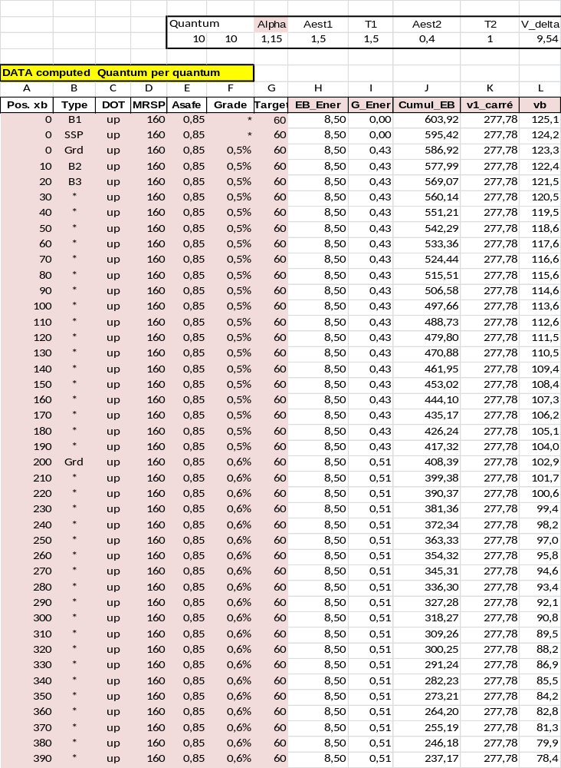Variables of speed limit
Pos. xb is the position of control at speed vb, incremental quantum=10 m. { m }

Type is the type of singular point ( “ * ”means no type).

DOT is up or down.

MRSP is the Most Restrictive Speed Profile ( compile SSP, TSR, Vmax..). { km/h }

Asafe is safe deceleration value, is a function of x and v0. { m/s² }
Formula : Asafe(n) = SI((v0 < 60); 0,80; 0,85)

Grade is slope grade, positive in uphill.

Target is the closest target speed, it can be : MRSP reduction, EOA, DP. { km/h }

EB_Ener is the Emergency Brake Incremental Energy. { m²/s² }
Formula : EB_Ener(n) = Asafe(n) * Quantum

G_Ener is the Grade Incremental Energy. { m²/s² }
Formula : G_Ener(n) = Grade * 9,81 * Quantum

Cumul_EB is cumul “EB_Ener +G_Ener”, since smallest target energy. { m²/s² }
Formula : Cumul_EB(n) = MIN( (Cumul_EB(n+1) + EB_Ener + G_Ener) ; ½ * (MRSP/3,6)² )

v1_carré is 2 times Kinetic energy of smallest target. { m²/s² }
Formula : v1_carré = ½ Target²

vb is max speed to respect smallest target without response time. { km/h }
Formula : vb = ( (RACINE( 2 * Cumul_EB )) * 3,6 )

v_delta is speed variation during the transition phase T1+ T2. { km/h }
Formula : v_delta = ((Aest1*T1) + (Aest2*T2)) * 3,6 )

v0 is max speed to respect smallest target with response time. { km/h }
Formula : v0 = vb – v_delta

Debc is running distance during response time. { m }
Formula : d = ½ ( (Aest1*T1²) + (Aest2*T2²) ) + ( Aest1* T1 * T2 )
Formula : Debc = d + (v0 * (T1+T2) / 3,6)

x0 is max position to respect smallest target with response time. { m }
Formula : x0 = xb - Debc

Track configuration

Simple Track Configuration is:

Balise : B1, B2, B3.

SSP : 160 km/h at position 0, 60km/h at position 160.

Grade changes at position 0, 200, 500, 610, 710, 820, 920, 1030, 1040, 1050,1080.

EOA at position 1060 with 30 km/h.

DP at position 1070.

Train Simulation (for model only)

Pos.xb is geographical milestone quantum per quantum of 10m = Pos(n)

Pos(0) is initiale position = 0 => Pos(n) = Pos(n-1) + 10
Pos(n+1) = Pos( n) +10

Aest is train acceleration => Aest( n ) = f ( v, n )

Vest is train speed at Pos(n) =>
Vest(n+1) = RACINE( (20 * Aest( n) ) + Vest(n)² )

Tdelta is time to reach Pos(n+1) and Vest(n+1)
Tdelta = (Vest(n+1) – Vest(n) ) / Aest(n)
Tdelta = { RACINE [ (20 * Aest( n) ) + Vest(n)² ] – Vest(n) } / Aest(n)

END OF DOCUMENT

